The days when fried chicken was synonymous with a certain white-haired southern gentleman are over, at least in the U.S. A new champion has claimed KFC’s long-held chicken crown: Chick-fil-A.
The change atop the leaderboard appears undisputed: Yum! Brands (YUM), which owns KFC and has for years prided itself as “the leader in the U.S. chicken [quick-service restaurant] segment,” removed that very phrase from the company’s most recent annual report.
View photo
.
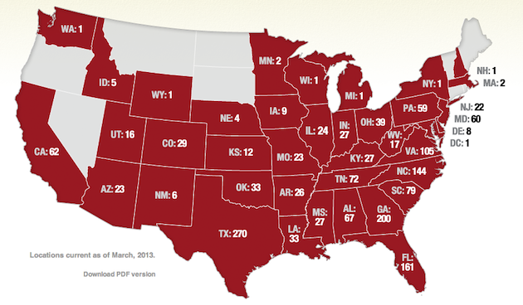
Source: www.chick-fil-a.com
Anyone in the northern half of the U.S. is likely scratching her head and wondering why she hasn’t seen Chick-fil-A outlets opening in the neighborhood. Last year Chick-fil-A only had about 1,775 U.S. stores to KFC’s 4,491, and most are in the South. Yet in dollar terms the Colonel is coming up short even with that much larger footprint: Chick-fil-A’s 2013 sales passed $5 billion, while all of KFC’s U.S. restaurants rang up about $4.22 billion, according to Technomic. And that’s with zero dollars coming in to Chick-fil-A on Sundays, when every restaurant is closed.
What Chick-fil-A lacks in store count, it makes up for in traffic. Each restaurant made about $3.2 million in 2013, more than three times as much as the average KFC at $938,000. Average sales at KFC restaurants have remained largely unchanged over the past decade, while they have climbed steadily at Chick-fil-A. Same-store sales climbed by more than 3.6 percent at Chick-fil-A last year; KFC’s fell by 2 percent.
KFC hit its U.S. peak by store count around 2004, when it had more than 5,500 restaurants—over four times the number of Chick-fil-A locations—and claimed 46 percent of the fast-food chicken market. But over the past decade the gap between the two narrowed as KFC closed stores and Chick-fil-A added more. Now, KFC’s storefront advantage is just 2.5 times more than its rival, and Chick-fil-A plans to chip away with more than 100 new locations opening this year. (A representative for KFC did not immediately respond to a request for comment.)
Darren Tristano, an executive vice president at consultancy Technomic, called Chick-fil-A one of the most successful fast-food chains. He cited the sizable breakfast business, an average check slightly higher than competitors’, and a menu that differentiates it from the big burger chains.
And fast-food chicken fans outside the South may not be puzzled by Chick-fil-A’s hegemony for long. A spokesman mentioned plans for locations in the “northern, Midwest, and western states,” where the company is now focusing its growth plans.

